THE UNITED REPUBLIC OF TANZANIA
PRESIDENT’S OFFICE
REGIONAL ADMINISTRATION AND LOCAL GOVERNMENT
ZONAL MOCK EXAMINATION
FORM FOUR-MARKING GUIDE
PHYSICS 2A
Solution
TABLE OF RESULT
b.
$$θ°$$ | r$°$ | Cos $θ$° | Sin r$°$
20 | 38 | 0.9397 | 0.6157
30 | 35 | 0.8660 | 0.5735
40 | 30 | 0.7660 | 0.5000
50 | 25 | 0.6428 | 0.4226
60 | 19 | 0.5000 | 0.3256
(0.5@15=7.5 Marks)
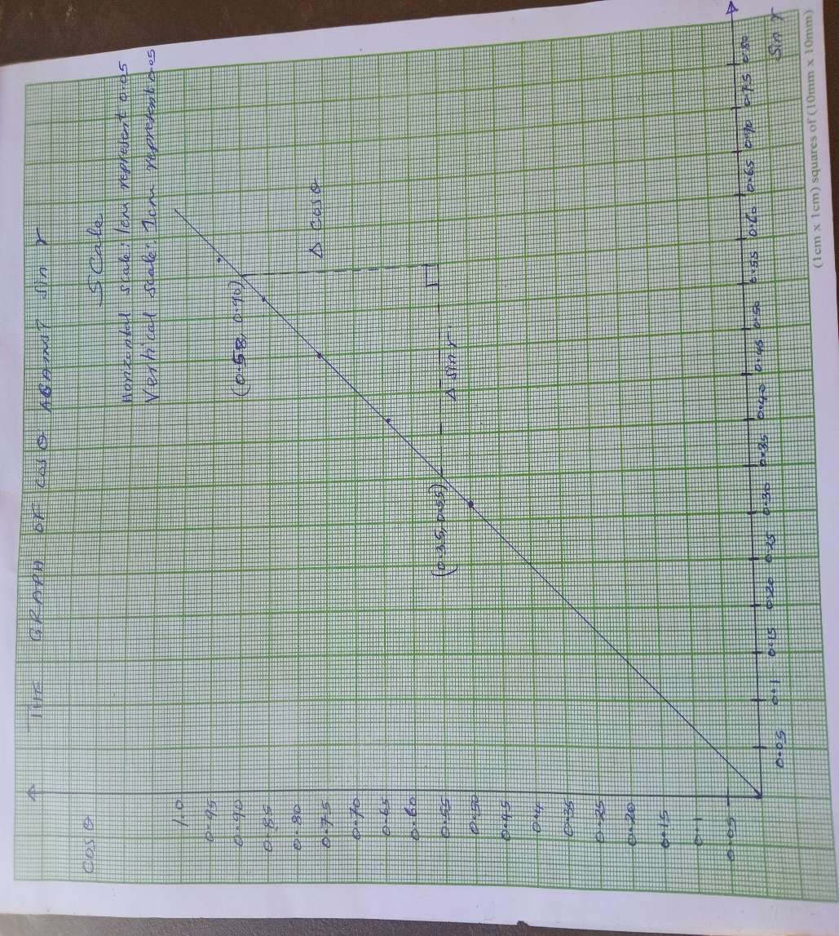
Title 01 Mark
Scale 01 Mark
SI=01 Mark
Bl = 01 Mark
T.p $\frac{1}{2}$ @ 05=2$\frac{1}{2}$ Marks

d. Slope (n) = $\frac{ΔCosθ}{ΔSin r}$ $\frac{1}{2}$ Mark
= $\frac{0.90-0.55}{0.58-0.35}$ $\frac{1}{2}$ Mark
= 1.5217
The slope of the graph is 1.52. 02 Mark.
e. The physical meaning of the slope of the graph is the refractive index of the glass block.
(01 Mark)
f. from the graph

$\frac{i}{n}$=Sin C
Sin c = $\frac{1}{1.52}$ 01 Mark
C=Sin⁻¹ $\frac{1}{1.52}$ ^{01 Mark}
C=sin⁻¹ (0.65789)
C=41.1395
C=41.14$°$ 01 Mark
Sources of error are
- Parallax error in measuring the angle by using protractor.
- Parallax error in replacing the glass block
- Parallax error in locating a pin.
01@02 Marks (Any two)
Precautions to be taken
- To be carefully in measuring the angle by protractor.
- To be carefully in replacing the glass block
- To be carefully in locating pins.
01@02 Marks (Any two)

2.
TABLE OF RESULTS
R($(Ω)$ | d(cm) | $$\frac{100}{d}$$
1 | 66.6 | 1.5
2 | 50 | 2
3 | 40 | 2.5
4 | 33.3 | 3
5 | 29 | 3.4
$\frac{1}{2}$ @10=05 Marks.
THEORY
R$∝$L
R$∝KL$

$\frac{R}{L}$ =K
$\frac{R1}{L1}$ = $\frac{R2}{L2}$ 01 Mark.
Let L1 = d
R1 = x
R2 = R
L2 = 100-d
$\frac{x}{d}$ = $\frac{R}{100-d}$ 01 Mark.
dR=(100-d)x
$\frac{dR}{d}$=$\frac{100x-dx}{d d}$
R= x $\frac{100-x}{d}$ 01 Mark.
Y= mx – c
M(slope) = x (UNKNOWN Resistance) 0.5 Mark.
Also
⁻C = X
C=X (Unkown resistance) 0.5 Mark.

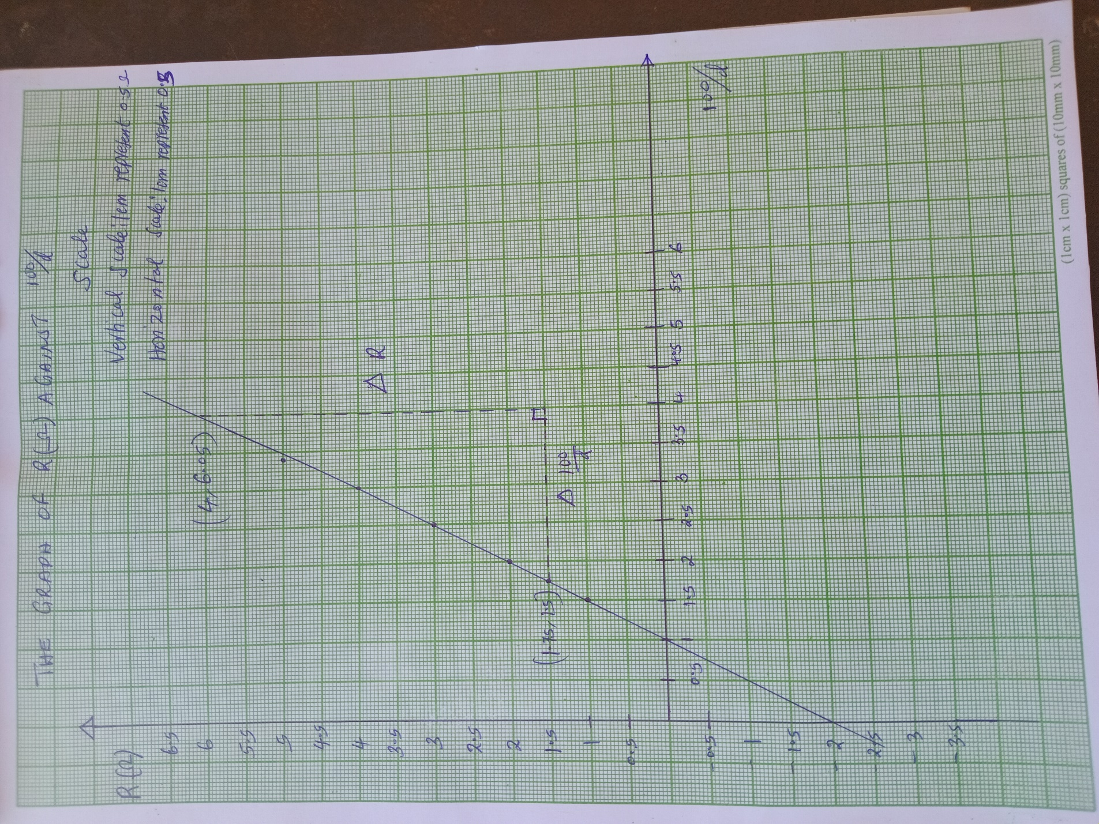
Title 01 Mark
Scale 01 Mark
SI 01Mark.
Bl 01 Mark.
Tp 2.5 Marks.
(b) from the graph
Slope (M) = $\frac{ΔR}{Δ{100}/d}$ 01Mark
=$\frac{(6.05-1.5)}{(4-1.75)}$ 01 Mark
=$\frac{4.55}{2.25}$
Slope (M=2.02 $Ω$
The slope of the graph is 2.02 $Ω$ 02 Marks.
(c) From the graph
Ro on R-axis is 2$Ω$ 02 Marks.
(d) To deduce value of x
Solution
Slope of the graph (M) = x
Slope = 2.02$Ω$
X=R-intercept (Ro)=2
$\frac{2+2.02}{2}$ 0.5 Mark.
X=2.01$≈2Ω$
The value of x is 2$Ω$ 01 Mark.
(e) The suitable title of this experiment is determination of unknown resistance by using metre bridge. 02 Marks.

